Weekly Construction Progress Report – Week 22
Harrow Bay Offshore Wind · 25 May – 31 May 2026
Elena Márquez · 01 June 2026 · HB-PM-RPT-2026-W22

1. Summary
1 monopile (HB-A08) was installed this week, bringing the total to 8 of 40. The foundation campaign is on the Rev 2 baseline. Waiting on weather amounted to 11 hours.
Area | Status | Comment
Overall schedule | Green | 8/40 monopiles vs. 8 planned
Foundations | Green | TPs installed: 7
Offshore substation | Green | Fabrication / load-out
Cables | Green | Manufacturing on schedule
HSE | Green | No incidents

2. Progress
Metric | This week | Cumulative | Plan (cum.) | Variance
Monopiles installed | 1 | 8 | 8 | +0
Transition pieces installed | 0 | 7 | – | –
Waiting on weather (h) | 11 | 143 | – | –
Persons on board (avg.) | 94 | – | – | –
Man-hours MV Sea Atlas | 7,780 | 65,224 | – | –
Lost time injuries | 0 | 0 | 0 | 0
Recordable injuries | 0 | 0 | – | –
Near misses reported | 0 | 2 | – | –
HSE observation cards | 24 | – | – | –

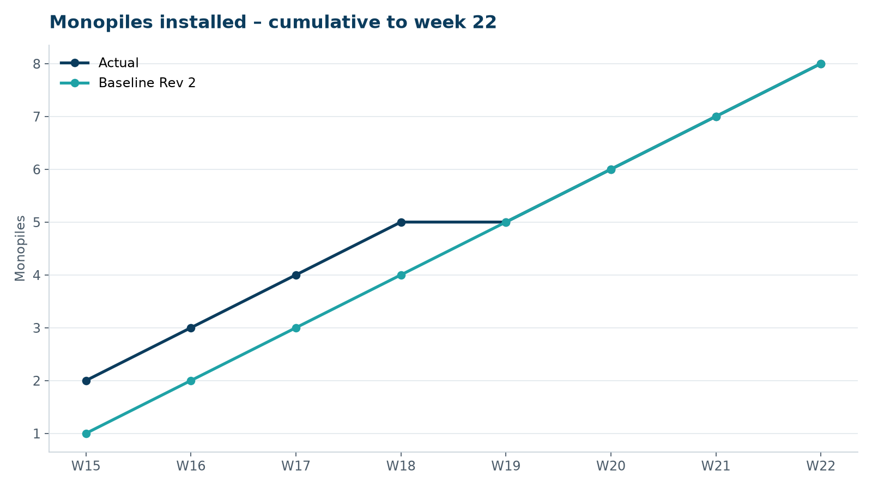
Figure 1 – Monopile installation progress, W15 to W22

3. Key activities this week
- HB-A08 installed on 30 May, the longest drive so far (4 h 34 min, 5,511 blows).
- Transition piece HB-A07 installed.
- Cumulative 8 of 40 monopiles – on baseline plan.

4. Health and safety
No lost time injuries. 24 observation cards submitted; top theme: access to the TP platform.

5. Environment
- HB-A08: peak 158.9 dB SEL at 750 m (compliant); pre-piling search clear, soft start on time.

6. Issues and risks
- HB-RISK-001 weather: 11 h downtime this week.

7. Look-ahead next week
TP HB-A08; load-out of HB-A09 to HB-A11.
Prepared by Project Controls (Gareth Lewis); approved by Elena Márquez. Distribution: project team, Steering Committee, Halden Turbine Systems, Lenders' Technical Adviser.

